**Critical Play Report – The Walking Dead**

Every game has its own space structure. Reasonable space structure is important for game design. In my opinion, the game *The Walking Dead* has elaborate space structures, because they are helpful to establish puzzles and narrate the story.

Space structure in *The Walking Dead* is very special. Every episode has multiple scenes. Each scene is structured by different but organized space. So that “space” in *The Walking Dead* seems like every single picture of a comic book. It is not a static one but interactive. Space is not an open world to explore. It is tiny, compact and rich. It contains helpful information for puzzle solving and the storytelling. As I mentioned before, space looks just like a single picture of a comic book. The Walking Dead is originally from a comic book. So that it may be reasonable to have such space structure to keep it has a feeling like it initial style.

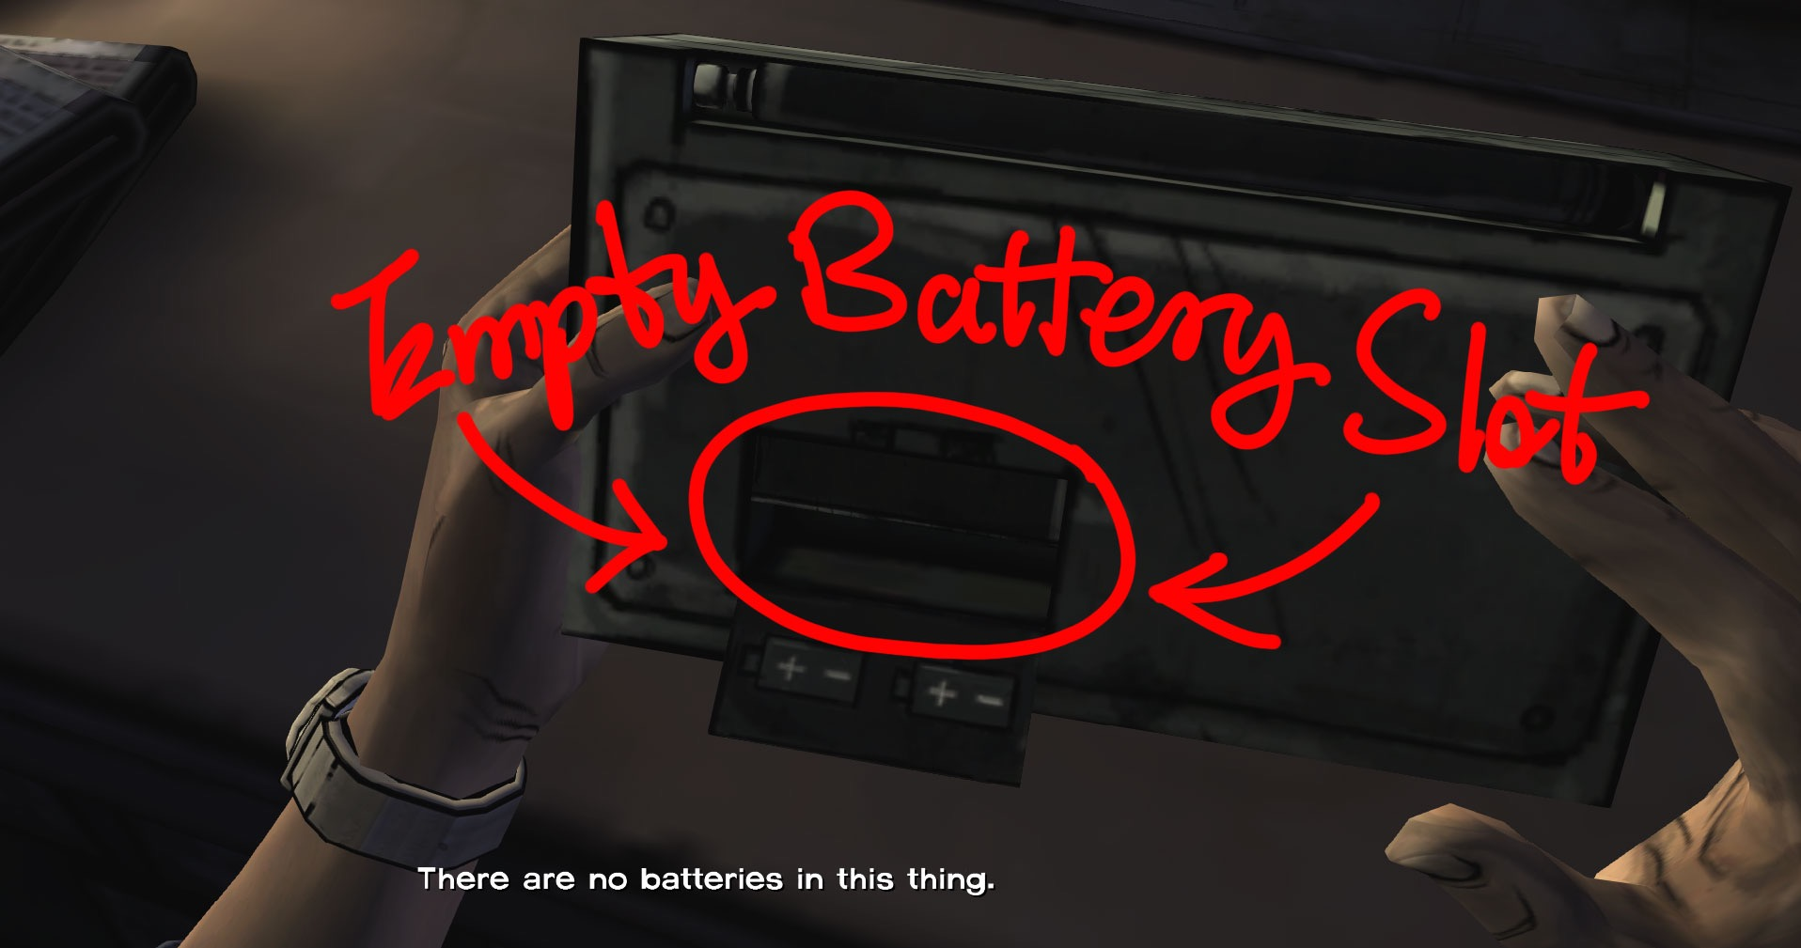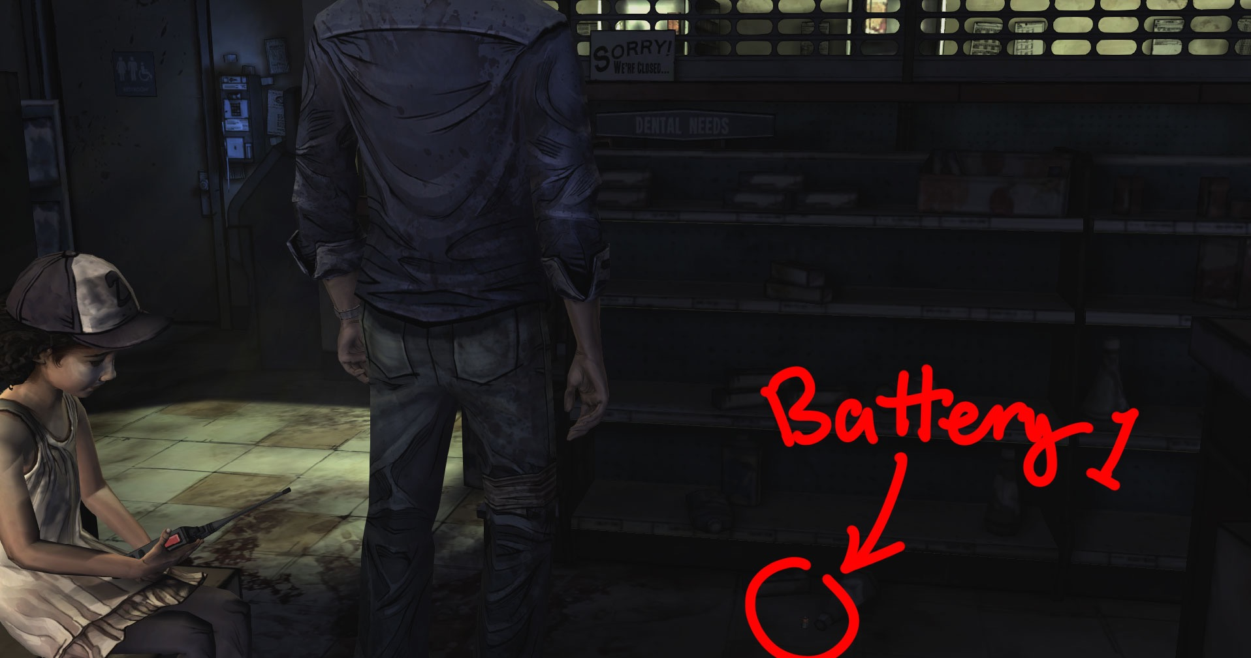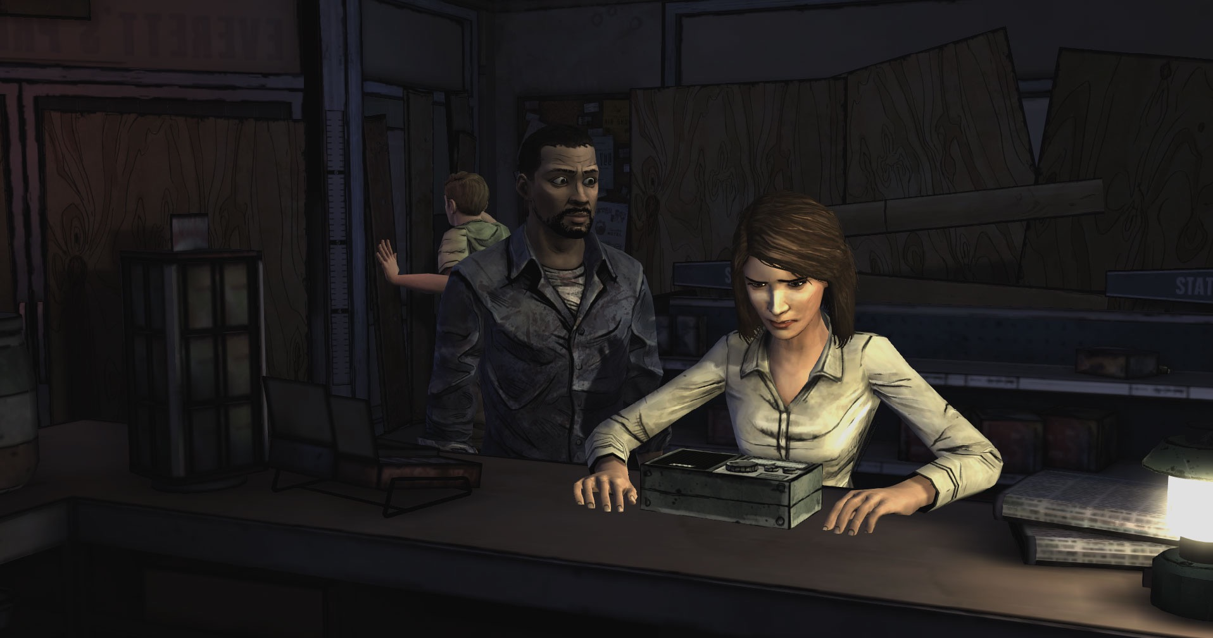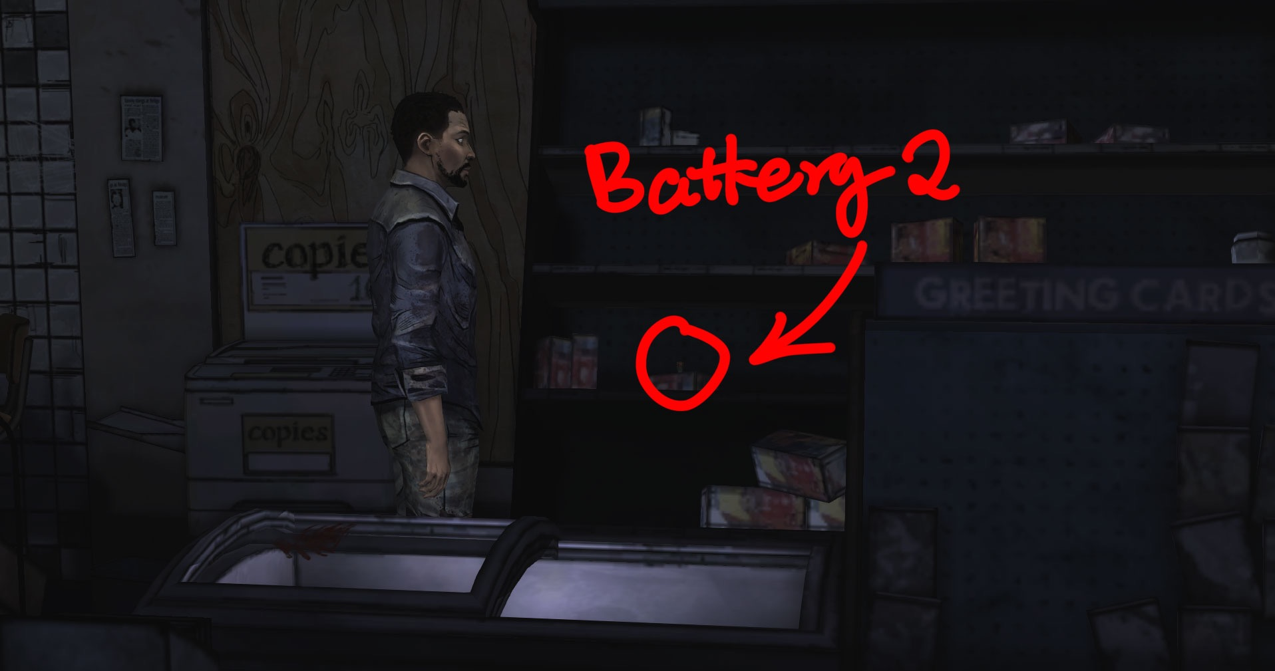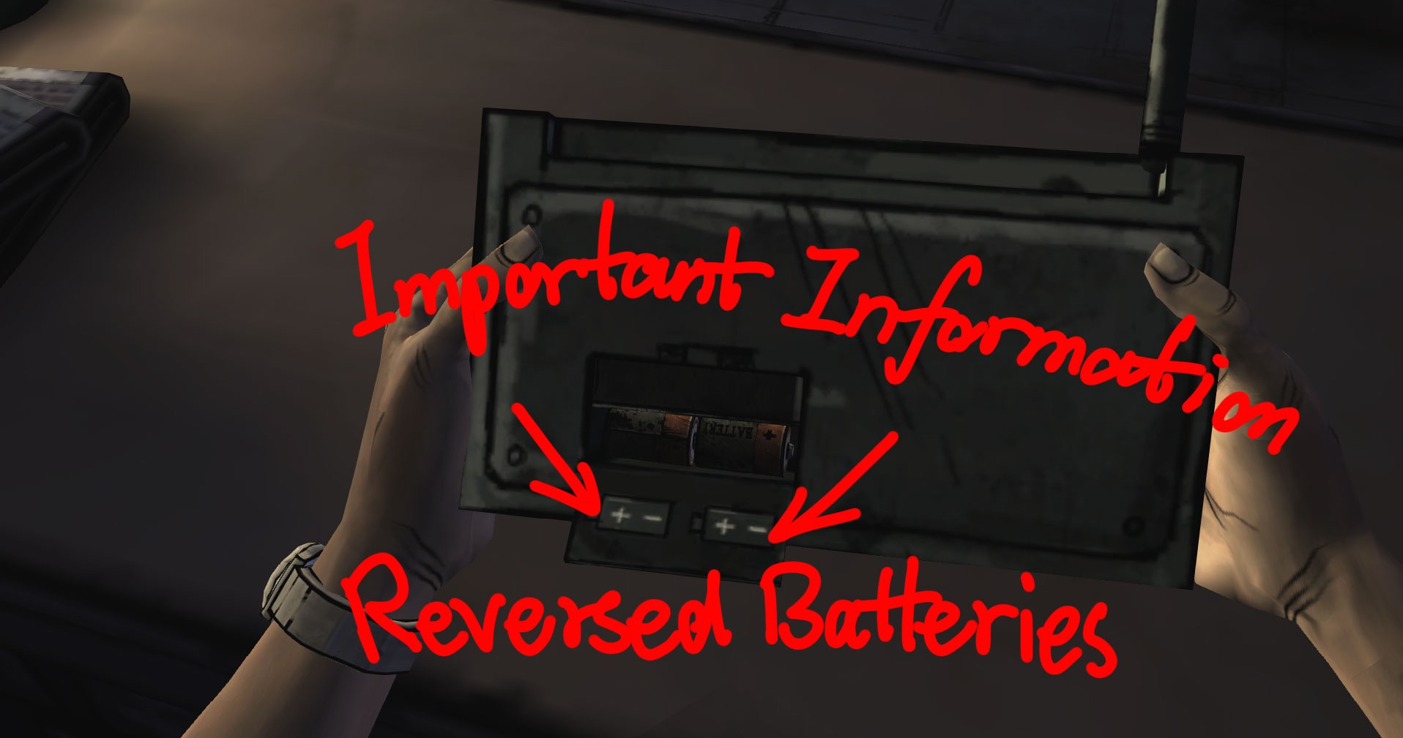First of all, tiny, but not easy. Space in “The Walking Dead” is small and compact, but nobody would say it is simple. Such limited space,not only gives us a feeling of a comic book but it is also easy to set puzzles. Full of destroyed construction, bloody zombies, messy objects and obstacles. Useful information and objects are just hidden behind and waiting for revealing. That is to say, player should control the protagonist to find important information, objects and hints that in game space. For an instance, in the game, Lee ( the protagonist) helps Carley (Woman in white blouse) fix a radio (Figure1). After checked the radio (Firgure2), Lee knows that the radio doesn’t work because of empty battery slot. He needs 2 batteries. In the current game space, Lee is in a grocery and

Figure1

Figure2

Figure3

Figure4

Figure5

maybe batteries are just here. We can move Lee around shelves and try to find batteries. As shown in Figure3, we can see a battery on the ground. Keep moving Lee along shelves we can help him find another battery (Figure4). Lee gives batteries to Carley, but the radio is still not working. Lee checks the radio again. Turn over the radio and we can realize that Carley installed batteries in a wrong direction. Lee reverses batteries to correct direction as important info shown on the slot lid. Radio works and we successfully solved a puzzle in the game. “The Walking Dead” sets puzzles following this rules in the whole game. Hints are hidden around the space. Space is not as big as an open world to explore, but full of information that makes it worth to explore.

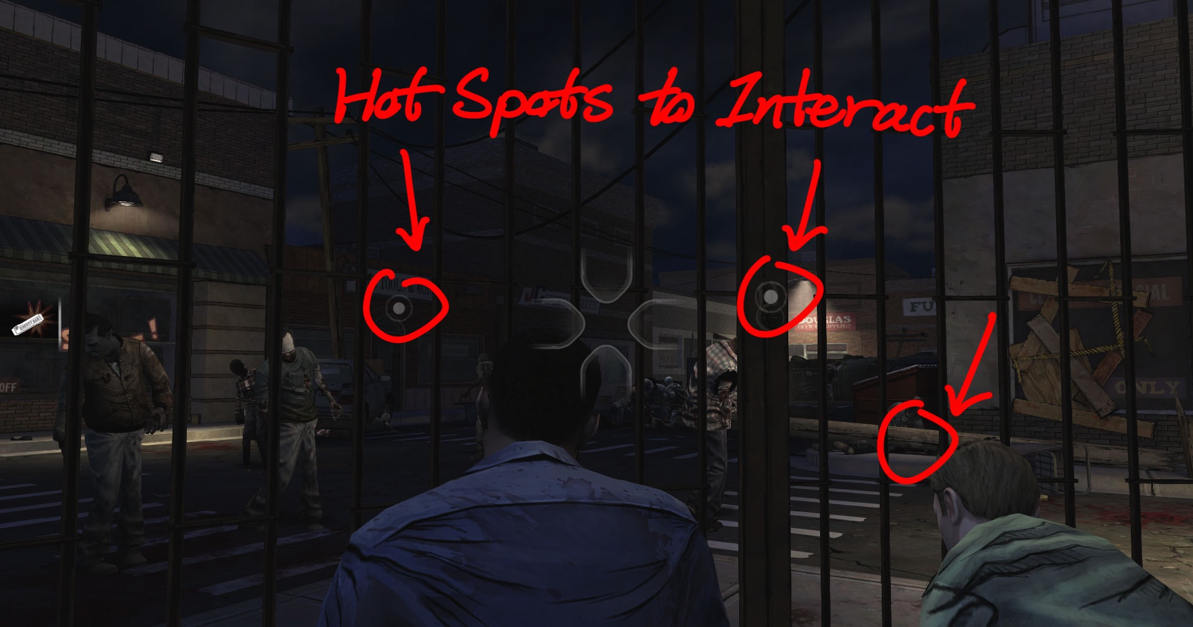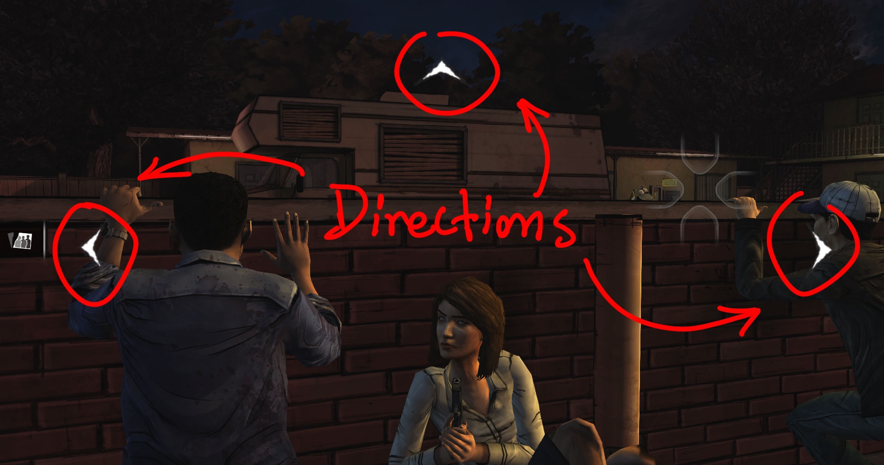Besides the space structure in The Walking Dead is helpful to set puzzles, it is also conducive to storytelling. To be more specific, the story in the game is set based on each single space. Every space is a part of the whole story. The player views each hot spot in a space, triggers an event or interacts with objects and other people. The whole story looks like a huge net build up with pieces in every single space. Here have two examples about story organization in *The Walking Dead*. The first one is shown in Figure6. Space is really limited. The protagonist Lee and a survivor, Doug, are behind the gate. There are three hotspots to interact for gathering information. Each spot contains useful information or clues to push story going forwards or solve puzzles. Figure7 shown another example. Lee has three directions to inspect the space. The story at this scene is around these 3 directions and order really matters in this environment. Lee should go left at first to take a pillow and then go right to kill a Zombie quietly with the pillow. Then take a spark plug to break the truck window glass for a screwdriver. Go back to the scene shown in Figure7. Then go up to kill another zombie with the screwdriver and follow the rest hot sports to complete the story at this scene and the next event will be triggered. Story is well organized by the limited space. And the compact space narrates the story naturally and player will definitely feel this is not only a game but also an interactive comic book.

Figure6

Figure7

In summary based on the above discussion, I believe that the space structure in The Walking Dead is helpful to establish puzzles and narrate the story. Player will have the feeling like reading a comic book rather than playing a game. Maybe this is a deliberate match that The Walking Dead is from a comic book.